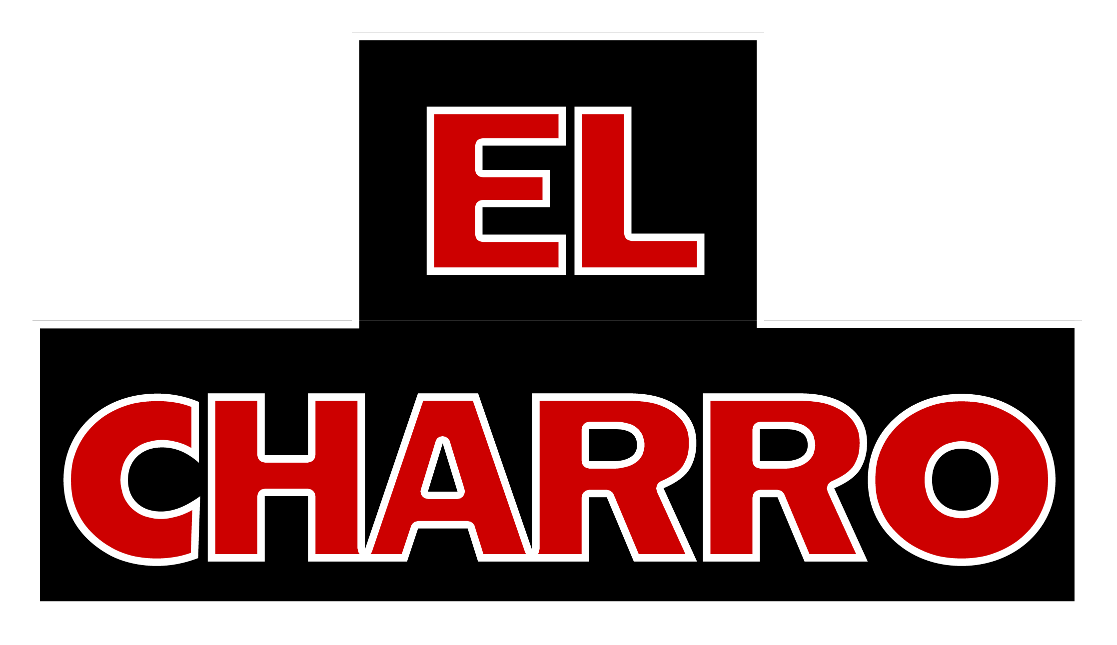

El Charro Plated Dinners On Premise
Served with tortilla chips, salsa, guacamole, arroz Sonoran, or arroz blanco ^{VG GF},
refried or Charro beans ^{VG.} Comes with choice of coffee, tea, or soda.

$20.00 Per Person El Charro Cafe Plated Dinners
Please preselect three (4) entrées from the below list for us to offer your guests the night of:
- Grilled sustainable cod soft tacos on flour tortillas – two per order ^{GF option}
- Grilled all natural chicken soft tacos on flour tortillas – two per order ^{GF option}
- Carnitas ranchero soft tacos on flour tortillas – two per order ^{GF option}
- Charro beef birria soft tacos on flour tortillas – two per order ^{GF option}
- Grass fed carne asada tacos – two per order ^{GF option}
- Pollo Arizona enchiladas in house-made red sauce and white cheese – two to an order ^{GF}
- Charro birria enchiladas in house-made red sauce and white cheese – two to an order ^{GF}
- Vegan nopalita enchilada – two to an order ^{GF, VG}
- Pollo Arizona burro- a mildly spiced, all white shredded natural chicken
- G Burro – veggie burro with grilled vegetables, corn tamale filling, green chile and avocado
- Carnitas ranchero burro – shredded green chile pork
- Family Recipe Carne Colorado burro – red chile beef
- Fresh corn, red chile beef, carnitas ranchero, chicken tomatillo, or tamales (2 per person) ^{GF}
- Classic Chile Relleno – the original Anaheim recipe

For $3.00 more per person per option, add:

- Cheese Crisps
- Fresh Guacamole ^{GF}
- Bean & Cheese Mini Chimichangas served with sour cream and pico salsa ^{VG} (2 per person)
- Churros with chocolate and caramel dipping sauces VG

For $5.00 more per person per option, add:
- Tres Leches Cake VG
- Homemade Flan ^{GF}

For $7.00 more per person per option, add:
- El Charro World Famous Carne Seca

$35.00 Per Person Carlotta’s Cocina Dinner

Served with an array of appetizers: Tortilla chips and salsa picante, mini chimis with sour cream and pico salsa, fresh guacamole, and cheese crisps with grilled green chiles

- Select one of Chef Carlotta’s special recipes: Reynosa Chicken
- Carlotta’s Classic Chicken Mole
- Pescado Tropical
- Grass Fed Charro Steak Asada
- Smoked “Costillas” Ribs Adobada
- Tamale Stuffed Chicken
- World Famous El Charro Carne Seca Platter
- Sinaloa Shrimp Culichi

Sides: Comes with Carlotta’s Salad and house-made calabacitas with arroz blanco and Charro beans

Dessert: Choice of Churros, Tres Leches Cake, or Flan

*Kids menus available. Please inquire about additional room and space fees, as charges may apply at each location. This menu is available at all locations and the Downtown El Charro location. Reservation time is based on 2 hours. Please allow for a 24-hour notice on all parties. All items are subject to tax and gratuity charge. Cash/hosted bar available. Patios are additional dining space, so other guests may be seated on the patio, depending on the size of your party. If weather or seating conditions arise on patio, your party may be moved indoors and provided a plated or family-style dinner. We do our best to accommodate desired seating space, but your party may be moved due to final size and restaurant seating.

