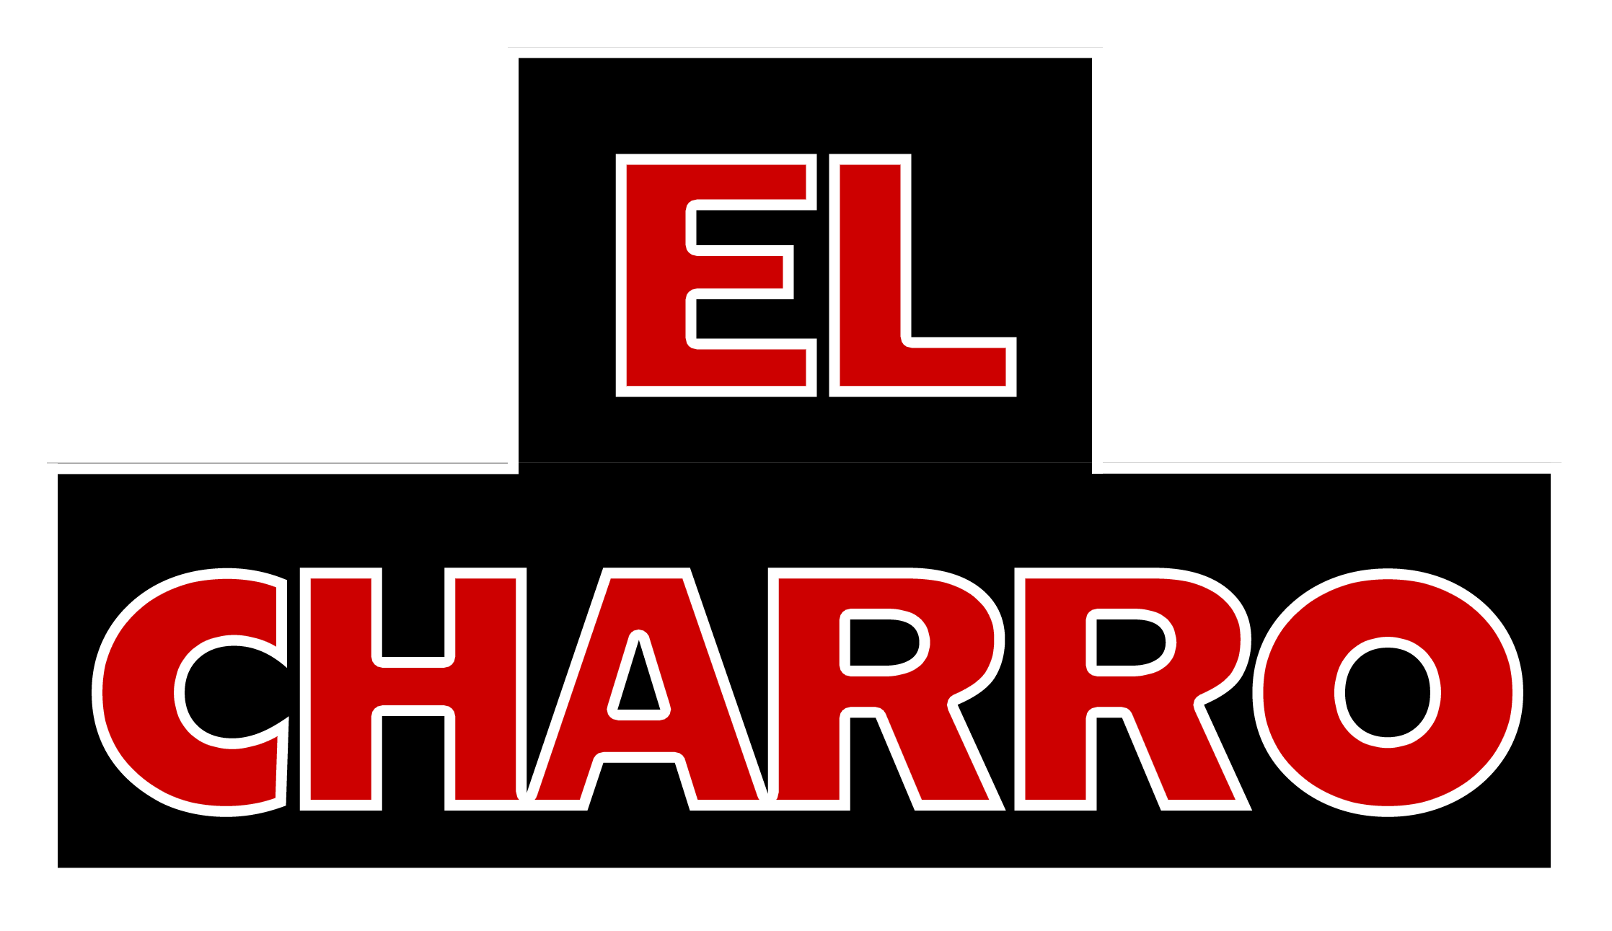

Off Premise Appetizer Buffet

El Charro Café Classic Fiesta $12.00 per person

Served with: Tortilla chips, salsa picante, and guacamole
Choose two (2) appetizer options served with sour cream and pico salsa:
Two (2) Rolled Chicken ^{GF}
Two (2) Mini Quesadillas ^{VG}
Three (3) Mini Chimichangas

Pick your two favorite sides to add to your fiests for $3.00 per person: arroz Sonora, arroz blanco, Charro beans, or frijoles refritos

El Charro Café Fiesta de Jardin $12.00 per person

Served with: Tortilla chips, salsa picante, and guacamole
Choose two (2) appetizer options served with sour cream and pico salsa:
Two (2) Mini Quesadillas ^{VG}
Three (3) Mini Chimichangas ^{VG}
Two(2) Vegan Tamale Stuffed Mushrooms ^{VG}

Pick your two favorite sides to add to your fiests for $3.00 per person: arroz Sonora, arroz blanco, Charro beans, or frijoles refritos

El Charro Nacho Bar $13.00 Per Person

Served with: Tortilla Chips, Salsa Picante, Pico de Charro, Garden Fresh Guacamole, Sour Cream, Queso Nacho Dip, Refried Beans, and Jalapenos

Your choice of one (1) El Charro Signature Recipe:
Pollo Arizona, Carnitas Ranchero, or Grilled Veggies

See our Fiesta Party Platter Menu for more options!

