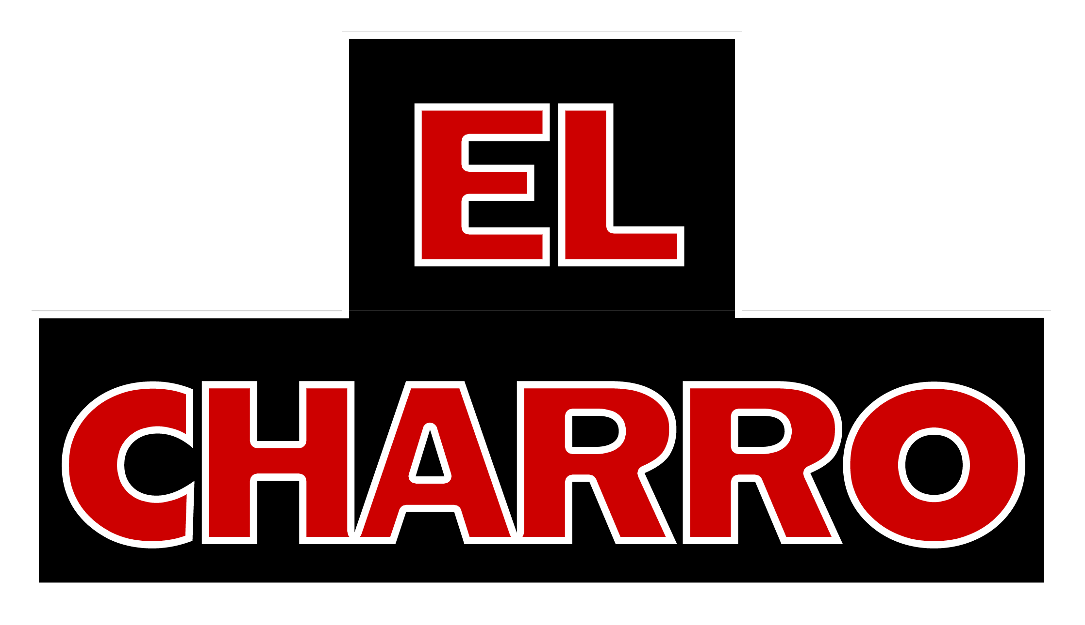

Off Premise Lunch Buffet

20-person minimum

Accompaniments: All buffets served with El Charro corn tortilla chips, salsa picante,
arroz Sonora or arroz blanco ^{VG GF}, Charro or refried beans ^{GF}, and flour tortillas.

$12.00 Per Person Dinner Buffet Options
Please preselect one (1) entrée from the below list for us to offer your guest the evening of. Lunch Buffet served with sour cream, pico salsa, and shredded cheese.

- Pollo Arizona ^{GF}
- Chicken Tinga ^{GF}
- Carnitas Ranchero ^{GF}
- Family Recipe Carne Colorado ^{GF}
- Charro Beef Birria ^{GF}
- Chilaquiles: An enchilada casserole with cheese ^{VG}
- Fresh corn, red chile beef, pork carnitas, chicken tomatillo, or tamales (1 per person) ^{GF}

For $3.00 more per person per option, add:

- El Charro fiesta greens salad with house vinaigrette or chipotle ranch ^{GF}
- Fresh Guacamole ^{GF}
- Bean & Cheese Mini Chimichangas served with sour cream and pico salsa ^{VG} (2 per person)
- Churros with chocolate and caramel dipping sauces VG

For $5.00 more per person per option, add:
- Tres Leches Cake VG
- Homemade Flan ^{GF}

For $7.00 more per person per option, add:
- El Charro World Famous Carne Seca

For 5.00 per person, per option add and additional beef or chicken entree:
- Charro Beef Birria ^{GF}
- Carnitas Ranchero ^{GF}
- Pollo Arizona ^{GF}
- Pollo Tinga ^{GF}

*This menu is available for pick-up at any location, delivery drop-off, or as a full-service, catered event. Full service includes full fiesta buffet set-up, chafing dishes, fiesta décor, and servers for an additional charge. Please inquire and see off-premise policy. Paper good are $1.00 per person and include a disposable plate, napkin, and cutler kit. Delivery drop-off in disposable serving platters is available for a 20% service charge on the total. Out of city limits orders may incur an out of town fee. Please allow for a 24-hour notice on all orders – a minimum of 20 people. All items are subject to tax and gratuity.

